INTERNATIONAL ENGAGEMENTS
Chapter 11  International Engagements

CHAPTER
11

11.1 INTERNATIONAL ENGAGEMENTS HAVING IMPLICATIONS FOR INDIAN MARKETS
SEBI actively engages with a range of foreign regulators, international standard-setting bodies and international fora to promote regulatory and enforcement co-operation. Further, SEBI also engages with peer securities market regulators in knowledge sharing to promote mutual co-operation and establish inter-regulatory dialogue. Some key engagements undertaken during 2025-26 are as follows:
- Engagement with IOSCO: The International Organization of Securities Commissions (IOSCO) is the international body that brings together the world’s securities regulators and is recognized as the global standard setter for the securities sector. SEBI is an ordinary member of IOSCO and also a member of the IOSCO Board. SEBI is a member of all the eight policy committees of IOSCO apart from being a member of its various other groups. Some of SEBI’s key engagements with IOSCO during 2025-26 are outlined below:
  - SEBI participated in meetings of IOSCO Board held during 2025-26, which inter alia discussed the following issues:
    - strengthening financial resilience
(ii) supporting market effectiveness (pre-hedging & valuations in asset management) (iii) protecting investors (launch of IOSCO’s I-SCAN) (iv) addressing risks in sustainable finance and fintech
(v) promoting regulatory cooperation and effectiveness, etc.
  - SEBI is also a member of IOSCO’s Board-level Financial Stability Engagement
Group (FSEG), which works towards enhancing IOSCO’s approach to financial stability issues, including with regard to its engagement with the FSB.
  - SEBI is a member of the Asia-Pacific Regional Committee (APRC) which is one of the four regional committees constituted by IOSCO to focus on regional issues relating to securities regulation. During the year, APRC discussed topics such as:
- online harms and investor protection
- technology, innovation and future of finance (c) public and private markets (d) supervisory and enforcement priorities in the region.
- Engagement with FSB: Financial Stability Board (FSB) is an international body which monitors and makes recommendations about the global financial system and promotes international financial stability. SEBI is one of the three members representing India on FSB. During the year, SEBI participated in discussions and provided inputs with respect to FSB’s recommendations on non-bank financial intermediation sector, vulnerabilities in private credit, digital innovation and operational resilience, etc. SEBI also participated in FSB’s survey on Regulatory and Supervisory Modernisation efforts.
- Other International Engagements
  - Memorandum of Understanding for International Co-operation: SEBI is a signatory to the IOSCO’s Multilateral Memorandum of Understanding (MMoU) for mutual co-operation and exchange of

information for enforcement purposes. Further, SEBI is also a signatory to the IOSCO’s EMMoU providing for extended co-operation w.r.t. obtaining and sharing audit work papers, compelling physical attendance for testimony, freezing assets, obtaining and sharing existing internet service providers’ records and telephone records.
SEBI has also signed bilateral MoU with several foreign securities regulators to enhance co-operation and information exchange for regulatory and enforcement purposes. As of March 31, 2026, SEBI is a signatory to 32 bilateral MoUs, which facilitate sharing of technical domain expertise and support effective enforcement of laws and regulations governing the securities market.
  - Exchange of Information with Foreign Regulators: The MoUs, including the IOSCO MMoU and EMMoU signed by SEBI, have been instrumental in facilitating information exchange with foreign counterparts for investigation and regulatory enforcement. Table 11.1 presents an overview of the regulatory assistance provided and received by SEBI.
  - Issue-specific Information Exchange- non enforcement matters: SEBI also engages with regulators/ organizations globally in order to exchange information on topical issues. During the year, information was exchanged on wide-ranging issues including credit ratings, settlement, automation of financial statements, sustainable finance, etc.
Table 11.1: International Regulatory Assistance

Type of References | 2024-25 | 2025-26
Requests received by SEBI from Foreign Authorities | 111 | 84
Requests made by SEBI | 37 | 54
- Engagements with Foreign Delegations/ Signatories: SEBI interacts with and hosts foreign delegations from governments, regulatory authorities, and market participants. These engagements enhance collaboration and promote a deeper understanding of the Indian securities market. A few prominent engagements are listed below:
  - An IMF staff team headed by Mr. Harald Finger, Assistant Director, and Mission Chief visited to understand the macroeconomic situation and financial risks and vulnerabilities with respect to India’s capital market, measures being undertaken to develop corporate bond markets and plans on implementing the recommendations of the IMF/ WB FSAP.
  - A delegation of Special Select Committee on Finance and Economy of the House of Representatives, Parliament of Malaysia led by Hon’ble YB Dato Indera Mohd Shahar Bin Abdullah, Member of Parliament for Paya Besar visited for discussion and exchange of views on various issues. (Image 1)
  - A team from OECD visited for peer review meetings on corporate governance of market service providers and ESG related developments.
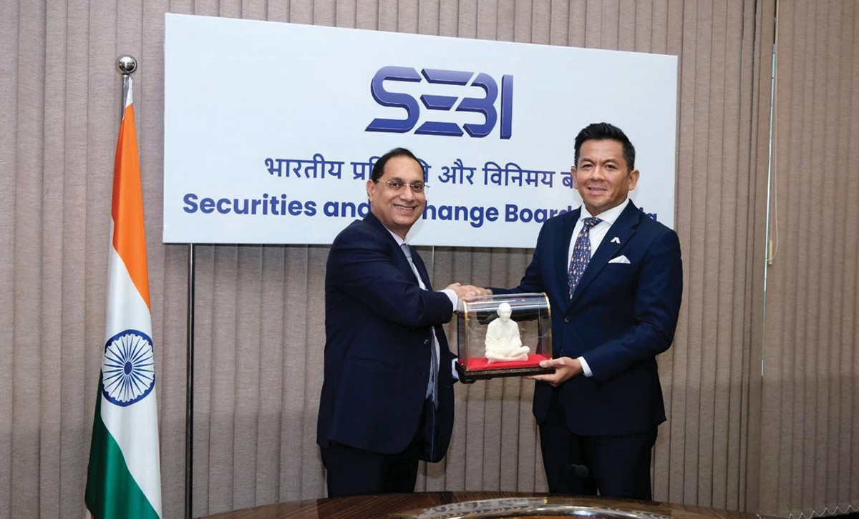
Image 1: Hon’ble YB Dato Indera Mohd Shahar Bin Abdullah, Member of Parliament for Paya Besar with SEBI Chairman

  - Mr. Yosef Zinger, Chairman, Israel Securities Agency (ISA) and officials discussed on enhancing collaboration and knowledge exchange between ISA and SEBI, strategic approaches to market development and challenges, etc.
  - A delegation of officials from TheCityUK and British High Commission, led by Mr. Miles Celic OBE, Chief Executive Officer, TheCityUK discussed areas of mutual interest.
  - Prof. Dr. Marlene Amstad, Chairperson, Swiss Financial Market Supervisory Authority discussed issues of mutual interest and co-operation.
  - A delegation from Indonesia headed by Mr. Thomas A.M. Djiwandono, Vice Minister of Finance, Republic of Indonesia discussed issues of mutual interest and co-operation.
  - Hon. André Ebanks, Premier and Minister of Financial Services and Commerce of the Cayman Islands, discussed areas of mutual interest. (Image 2).
  - Mr. Herman Gref, CEO of Sberbank, and Russian delegation discussed areas of mutual interest and possible collaboration. As part of the visit, Sberbank and JSC First Asset Management, introduced a new mutual fund, First-India, offering investments linked to the performance of the Nifty50 Index, providing Russian retail investors an opportunity to directly participate in India’s stock market.
  - A delegation from Financial Conduct Authority(FCA),UKdiscusseddevelopments on international investments into India from asset managers and institutional investors. The delegation was led by Ms. Camille Blackburn, FCA’s Director for Asia-Pacific.
  - H.E. Mr. Gilles Roth, Minister of Finance of Luxembourg, along with H.E. Mr. Christian Biever, Ambassador of the Grand Duchy of Luxembourg to India, Mr. Claude Marx, Director General, CSSF Luxembourg, and other senior officials discussed issues of mutual interest and co-operation. (Image 3)

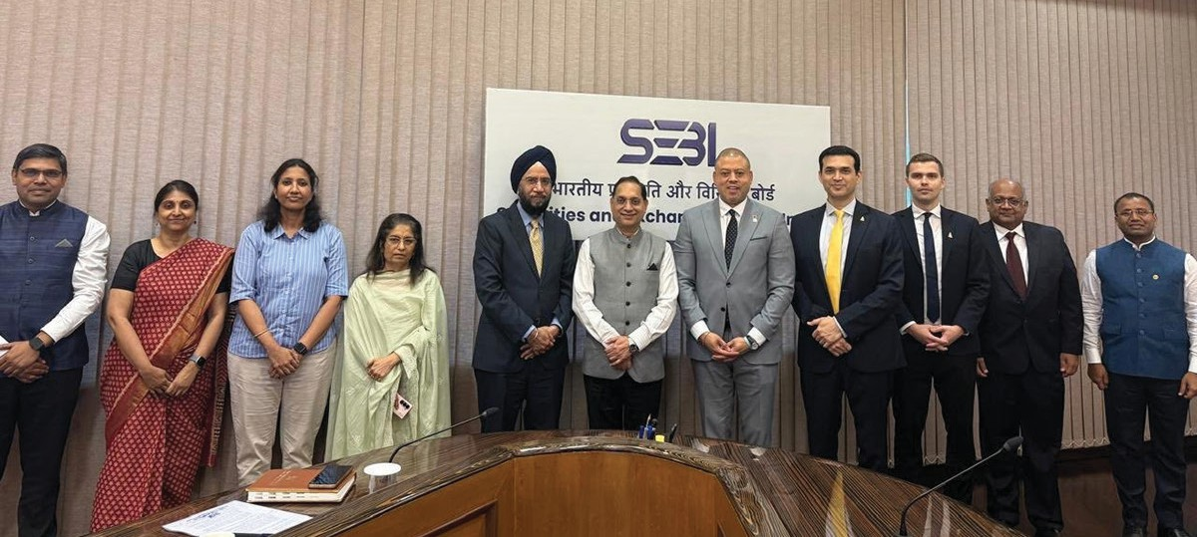
Image 2: Hon’ble André M. Ebanks, Premier of the Cayman Islands and team along with Chairman, SEBI and team.

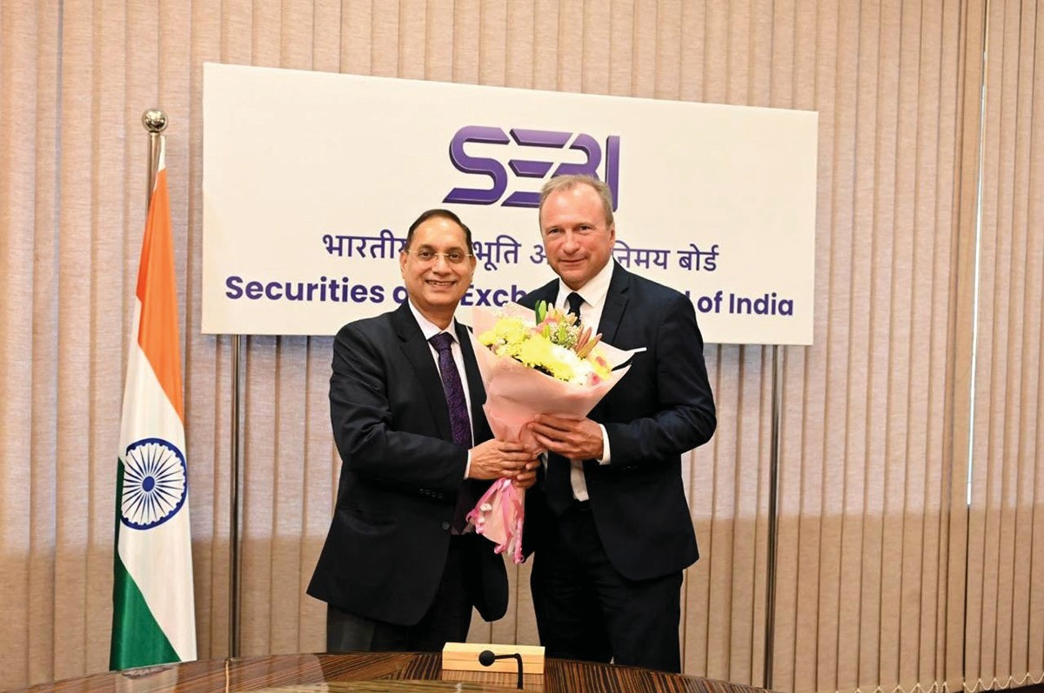
Image 3: H.E. Mr. Gilles Roth, Minister of Finance of Luxembourg along with Chairman, SEBI

  - Mr. Francois-Philippe Champagne, Honourable Minister of Finance, Canada to discuss issues on facilitating investments and collaboration. (Image 4)
  - Officials from Colombo Stock Exchange led by Ms. Punyamali Saparamadu, Senior Vice President visited SEBI to discuss operational frameworks of derivatives exchange and ETFs.
  - Russian delegation consisting of National Settlement Depository, Central Bank of Russia (CBR), led by Mr. Maxim Leonov, Head of Workstream (BRICS Co-ordinator), Department for Co-operation with International Organizations, CBR discussed areas of mutual co-operation.
- Facilitation of study tours for foreign authorities

  - SEBI facilitated a 4-day study tour for the delegates from CMSA Tanzania headed by Mr. Nicodemus D. Mkama, CEO, CMSA. SEBI also facilitated dialogues with the National Stock Exchange, the Indian Venture Capital Association, and interactions with leading fund managers that illuminated the practical insights into the subject.
  - A senior level delegation from Securities Commission, Malaysia headed by Ms. Azalina Adham, Managing Director, visited SEBI for bilateral engagements. The delegation also interacted with officials

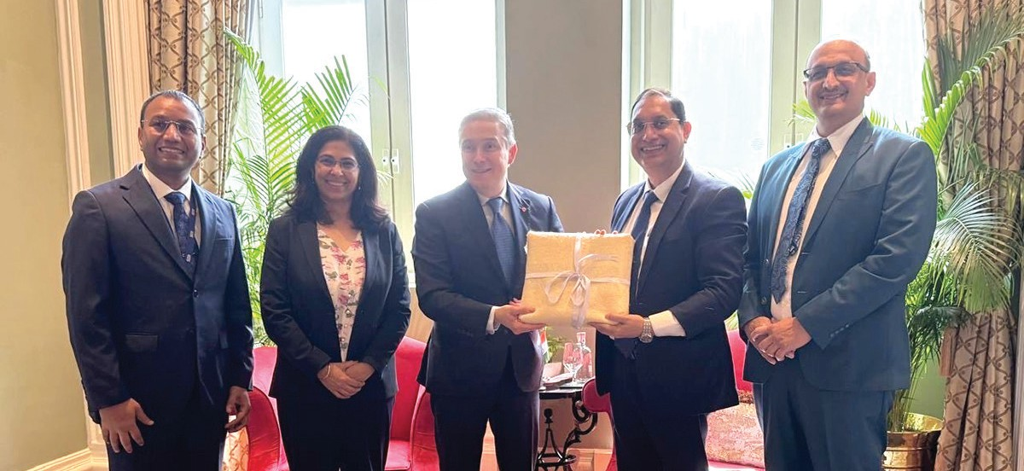
Image 4: Mr. Francois-Philippe Champagne, Honourable Minister of Finance, Canada along with Chairman, SEBI and team

of NISM on capacity building and had an interaction with SEBI Chairman for areas of mutual interest and possible future collaborations.
- SEBI’s participation in various international forums
  - During September 2025, Chairman, SEBI participated in a panel discussion on Artificial Intelligence organised by Autorité des Marchés Financiers, France and Association Europe-Finances-Regulations in Paris.
  - During October 2025, Chairman, SEBI participated in a panel discussion at the OECD Roundtable on Corporate Sustainability Practices in Paris and talked about Corporate sustainability-related disclosures.
  - During March 2026, Chairman, SEBI participated in a fireside chat on “The India Story: Growth and opportunity” during ASIFMA 2026 Annual Conference in Sydney,
Australia. The fireside chat was moderated by Mr. Peter Stein, Chief Executive Officer, ASIFMA.
- Contribution to various International Treaties, Dialogues, visits by/ of high level dignitaries
  - During 2025-26, SEBI provided inputs on various issues, agenda items and topics relating to the securities markets for international dialogues. SEBI contributed to such dialogues with countries including UK, USA, EU, France, Germany, New Zealand, Japan, Israel, Korea etc.
  - SEBI provided inputs for high-level bilateral meetings/ engagements with the foreign dignitaries viz. Netherlands, Germany, France, USA, Israel, Japan, Russia, Singapore, Indonesia, Austria, Canada, Maldives, Luxembourg, Switzerland, Liechtenstein, etc.
  - SEBI also provided inputs for various Free Trade Agreements (FTAs) negotiations of India with USA, UK, New Zealand, Maldives

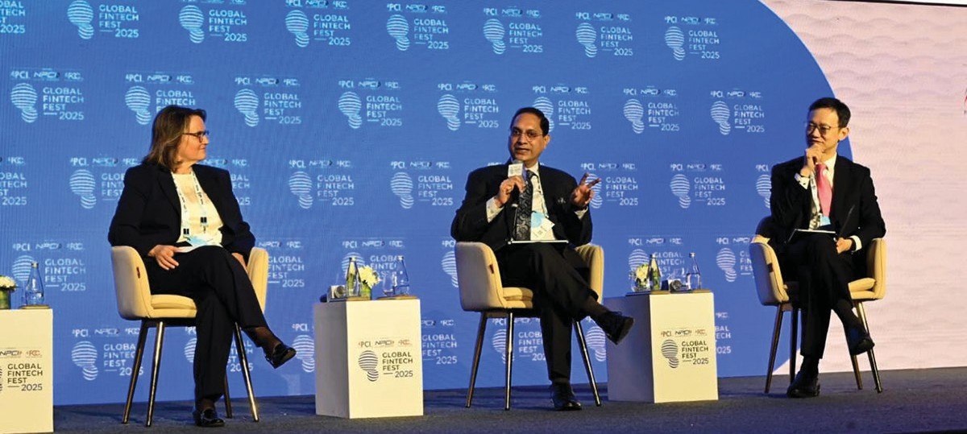
Image 5: Prof. Dr. Marlene Amstad, Chairperson, Swiss Financial Market Supervisory Authority, Mr. Tuang Lee Lim, Assistant Managing Director, Monetary Authority of Singapore and Chairman, SEBI during a panel discussion at GFF 2025.

Table 11.2: Ministry References Including FTA

Year No. of references
2024-25 252
2025-26 173
and EU on ‘financial services chapter’. The number of Ministry references received in last two years is given in Table 11.2.
- SEBI’s participation in Global Fintech Fest (GFF) 2025: GFF has evolved into one of the world’s largest fintech platforms, bringing together regulators, innovators, industry leaders and academia to deliberate on the future of financial ecosystem. During GFF 2025, IOSCO Board Chairman Mr. Jean-Paul Servais gave a virtual keynote address. Chairman, SEBI had also gave a keynote address on Technology-led
transformations in capital market and navigating the risks of technology. GFF 2025 also saw a high level panel discussion on ‘Resilient and Inclusive Capital markets in a tech-driven world’ between Mr. Tuang Lee Lim, Assistant Managing Director, Monetary Authority of Singapore, Prof. Dr. Marlene Amstad, Chairperson, Swiss Financial Market Supervisory Authority and Mr. Tuhin Kanta Pandey, Chairman, SEBI. (Image 5)
- Financial Sector Assessment Programme: The Financial Sector Assessment Program (FSAP) is a joint program of IMF and World Bank that undertakes a comprehensive and in-depth analysis of a country’s financial sector. The IMF and World Bank had jointly initiated the 2024 FSAP for India (Box 11.1).

Box 11.1: Transforming India’s Financial Architecture- Key Insights from World Bank’s Financial Sector Assessment

On the basis of the assessment carried out in 2024, the World Bank released the India - Financial Sector Assessment (FSA) Report on October 30, 2025. The report observes that against a backdrop of robust macroeconomic growth, India’s financial system has become more resilient, diversified, and inclusive since the last assessment in 2017. While reforms have helped the economy navigate past distress episodes and the pandemic, further impetus is required to support the India’s goal of becoming a USD 30 trillion economy by 2047.
Acknowledging the world-class status of India’s Digital Public Infrastructure, the assessment recommends that last-mile reach and account usage be further improved, while simultaneously strengthening market conduct oversight against emerging digital fraud risks.
The key insights and takeaways pertaining specifically to India’s capital markets and the role of SEBI are outlined below:
- Capital Market Growth & Infrastructure: India’s capital markets (equity, government bonds, and
corporate bonds) have grown from 144 percent to approximately 175 per cent of GDP since the 2017 assessment, backed by a robust market infrastructure. The mutual fund industry’s AUM has grown from 6 to 16 per cent of GDP over the last decade, driven by a significant influx of retail investors into equity funds.
- Proactive Regulation & Supervision: SEBI has proactively bolstered the regulatory framework by enhancing collateral management, establishing CDMDF and pioneering frameworks for sustainable finance and social stock exchanges. However, industry stakeholders note that the increasing volume of rules can sometimes affect flexibility and market competitiveness. The report advises SEBI to transition from an excessive reliance on upfront disclosures towards an integrated, risk-based supervisory approach that proactively monitors conduct and systemic risks such as inter-sectoral contagion from mutual funds.

(Contd.)

- Investor Base: The investor base is diverse and segmented across asset classes. Yet key barriers continue to limit their role in financing long-term investments and infrastructure. DIIs are still excessively risk averse and need to enhance their risk assessment capabilities.
- Modernizing the Corporate Bond Market: Despite the expansion of outstanding issuances, the corporate bond market remains relatively small (around 16 percent of GDP). To develop a deeper and more vibrant bond market, the report recommends relaxing restrictions to allow institutional financing of sub-investment-grade assets, developing credit enhancement mechanisms, and encouraging institutional capacity building for risk assessment.
- Investor Protection and Intermediary Oversight: With the surge in retail participation, there is a strong need to mitigate mis-selling and monitor conduct risks at the point of sale, particularly for distributors dealing with multiple funds. The assessment recommends that SEBI simplify key
explanatory documentation regarding investment risks and fee structures for retail investors. Furthermore, the report notes that while the first-level regulator model has proven effective for MIIs, relying on unsupervised entities like AMFI to manage large number of distributors poses oversight risks and recommended that SEBI be granted explicit authority to designate and supervise such entities as formal SROs when appropriate.
- Sustainability and Emerging Risks: While the financial sector’s exposure to physical and transition risks appears manageable, there is a risk of spillover from concentrated energy-sector exposures of NBFIs to capital markets and lenders. While SEBI has taken measures such as introducing frameworks for sustainable investments and preventing greenwashing, the report advises authorities to incorporate climate and environmental risks within macro-prudential surveillance and develop system-wide stress-testing methodologies.

